Lab 9 – On-Premises Data gateway

Create and publish a Power BI Desktop file
Use the following procedure to create a basic Power BI report using the AdventureWorksDW2020 sample database. Publish the report to the Power BI service, so that you get a dataset in Power BI, which you can then configure and refresh in subsequent steps.
- In Power BI Desktop, on the Home tab, select Get data > SQL Server.
- In the SQL Server database dialog box, enter the Server and Database (optional) names, make sure the Data Connectivity mode is Import, and then select OK.
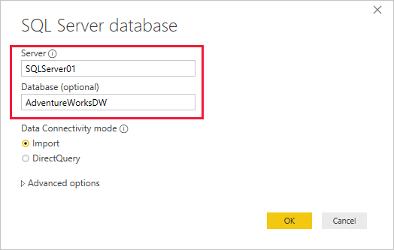
We're not using Advanced options in this tutorial, but note that you can specify a SQL statement and set other options like using SQL Server Failover.
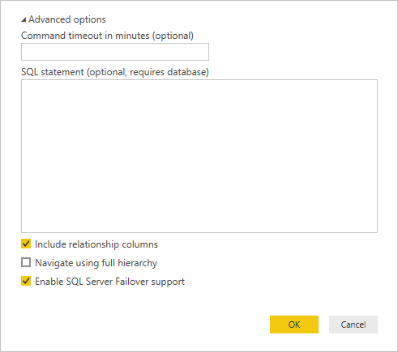
- Verify your credentials, then select Connect.
Note
If you're unable to authenticate, make sure you select the correct authentication method and use an account with database access. In test environments, you might use Database authentication with an explicit username and password. In production environments, you typically use Windows authentication. Refer to Troubleshooting refresh scenarios and contact your database administrator for additional assistance.
- If an Encryption Support dialog box appears, select OK.
- In the Navigator dialog box, select the DimProduct table, then select Load.
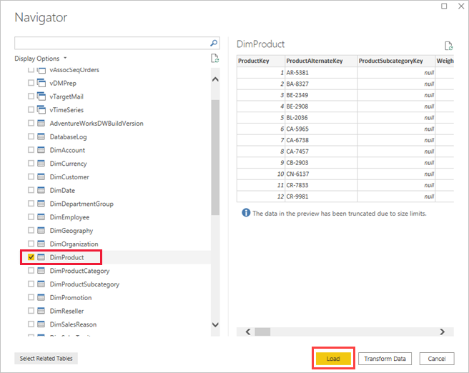
- In the Power BI Desktop Report view, in the Visualizations pane, select the Stacked column chart.
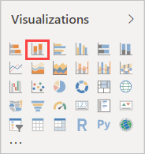
- With the column chart selected in the report canvas, in the Fields pane select the EnglishProductName and ListPrice fields.
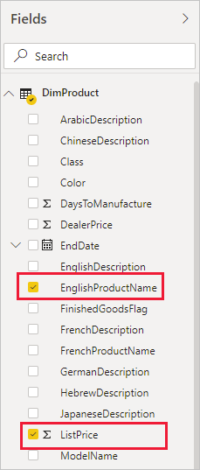
- Drag the EndDate onto Filters on this page, and under Basic filtering select only the checkbox for (Blank).
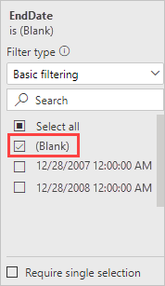
The chart should now look like the following.
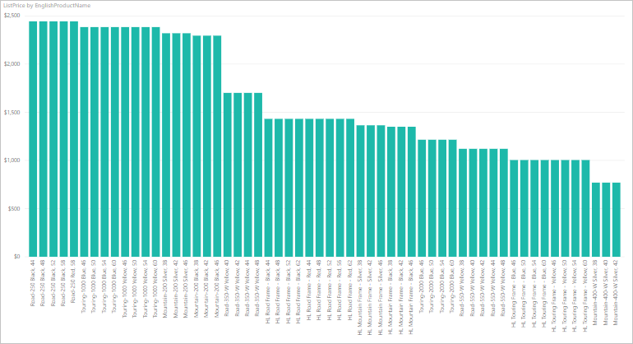
Notice that the five Road-250 products are listed with the highest list price. This will change when you update the data and refresh the report later in this tutorial.
- Save the report with the name "AdventureWorksProducts.pbix".
- On the Home tab select Publish > My Workspace > Select. Sign in to the Power BI service if you're asked to do so.
- On the Success screen, select Open 'AdventureWorksProducts.pbix' in Power BI.
Publish to Power BI

Connect a dataset to a SQL Server database
In Power BI Desktop, you connected directly to your on-premises SQL Server database, but the Power BI service requires a data gateway to act as a bridge between the cloud and your on-premises network. Follow these steps to add your on-premises SQL Server database as a data source to a gateway and then connect your dataset to this data source.
- Sign in to Power BI. In the upper-right corner, select the settings gear icon and then select Settings.
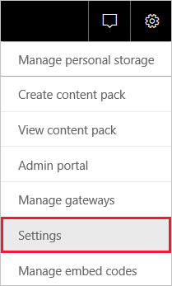
- On the Datasets tab, select the dataset AdventureWorksProducts, so you can connect to your on-premises SQL Server database through a data gateway.
- Expand Gateway connection and verify that at least one gateway is listed. If you don't have a gateway, see the Prerequisites section earlier in this tutorial for a link to the product documentation for installing and configuring a gateway.
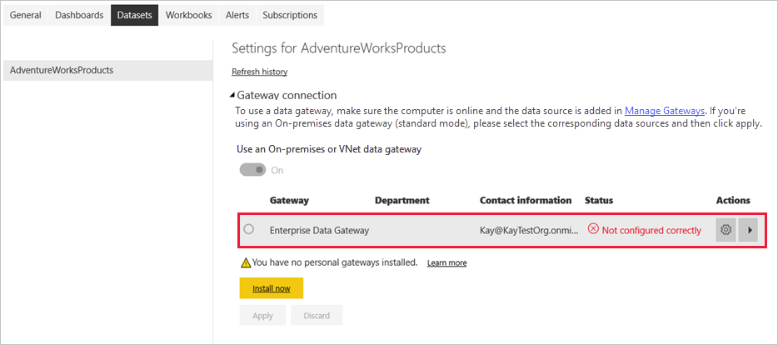
- Under Actions, expand the toggle button to view the data sources and select the Add to gateway link.
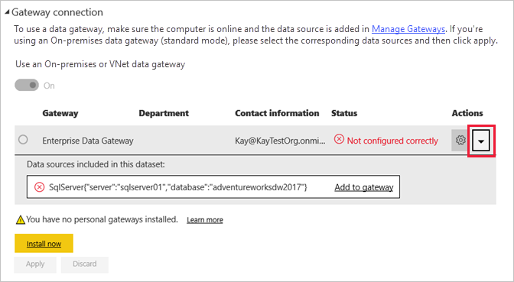
Note
If you're not a gateway administrator and don't want to install a gateway yourself, contact a gateway administrator in your organization. They can create the required data source definition to connect your dataset to your SQL Server database.
- On the Gateways management page, on the Data Source Settings tab, enter and verify the following information, and select Add.
TABLE 1
Option | Value
Data Source Name | AdventureWorksProducts
Data Source Type | SQL Server
Server | The name of your SQL Server instance, such as SQLServer01 (must be identical to what you specified in Power BI Desktop).
Database | The name of your SQL Server database, such as AdventureWorksDW2020 (must be identical to what you specified in Power BI Desktop).
Authentication Method | Windows or Basic (typically Windows).
Username | The user account you use to connect to SQL Server.
Password | The password for the account you use to connect to SQL Server.
- 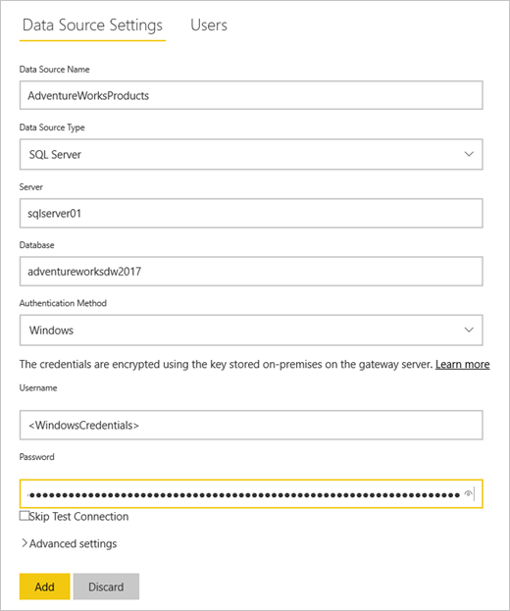
- On the Datasets tab, expand the Gateway connection section again. Select the data gateway you configured, which shows a Status of running on the machine where you installed it and select Apply.
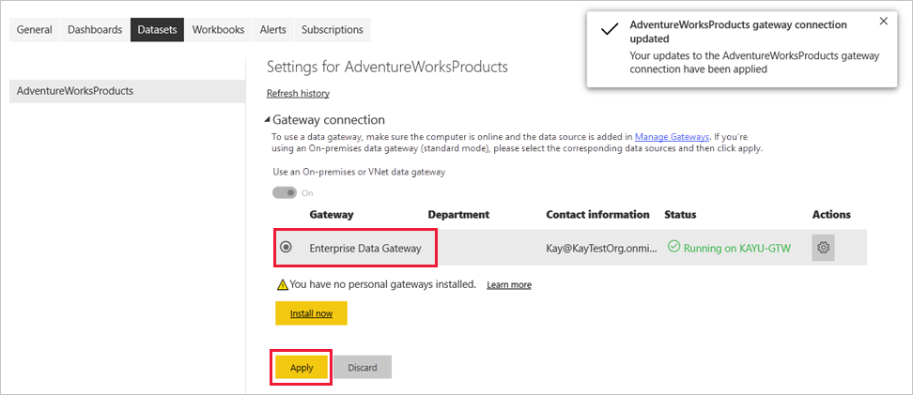

Configure a refresh schedule
Now you've connected your dataset in Power BI to your SQL Server database on-premises through a data gateway, follow these steps to configure a refresh schedule. Refreshing your dataset on a scheduled basis helps to ensure that your reports and dashboards have the most recent data.
- In the nav pane, open My Workspace > Datasets. Select the ellipsis (. . .) for the AdventureWorksProducts dataset, then select Schedule refresh.
Note
Make sure you select the ellipsis for the AdventureWorksProducts dataset and not the ellipsis for the report with the same name. The context menu of the AdventureWorksProducts report does not include a Schedule refresh option.
- In the Scheduled refresh section, under Keep your data up to date, set refresh to On.
- Select an appropriate Refresh frequency, ( Daily for this example), and then under Time, select Add another time to specify the desired refresh time (6:30 AM and PM for this example).
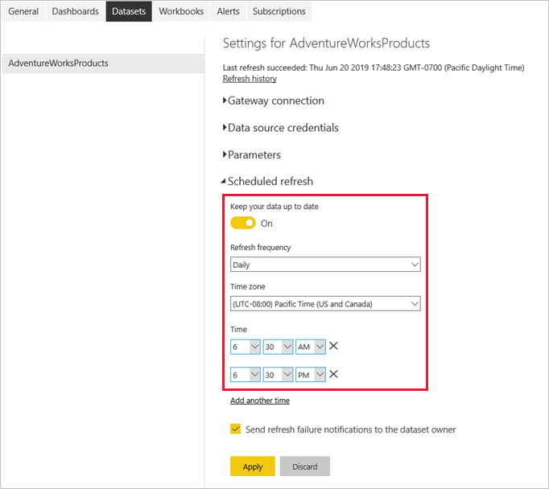
Note
You can configure up to 8 daily time slots if your dataset is on shared capacity, or 48 time slots on Power BI Premium.
- Leave the checkbox Send refresh failure notification emails to me enabled and select Apply.

